Day 09 to 15
Food choice website :

-> This created website is for known ideas about recipe which will offer different food and then proceeds towards which dish you select and after it know ideas about that recipe .

-> Some coding of this website is shown as below.

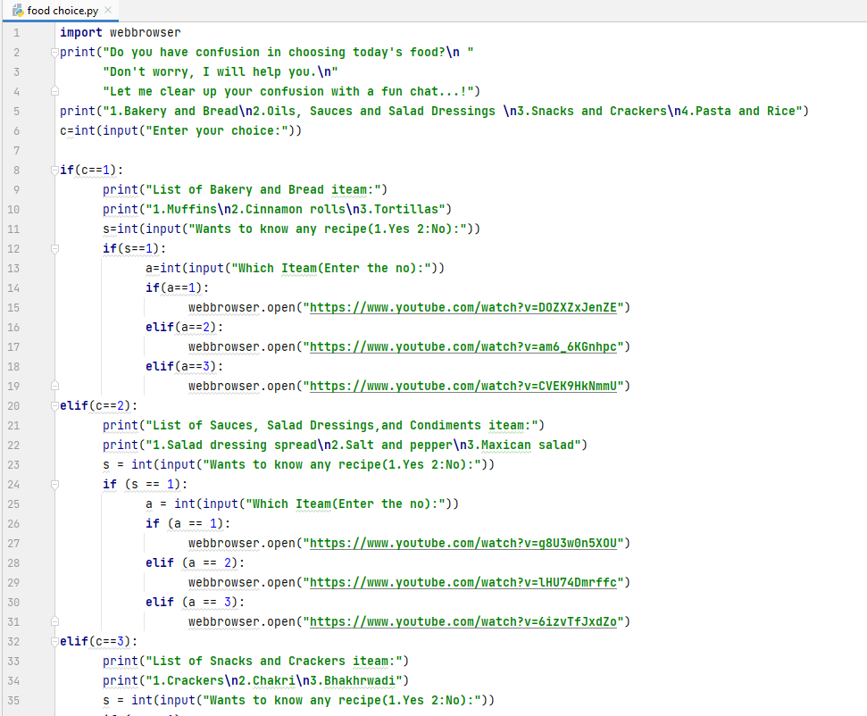

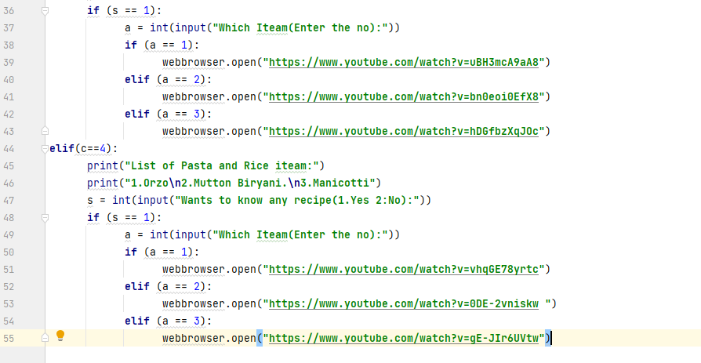
Output 1 :

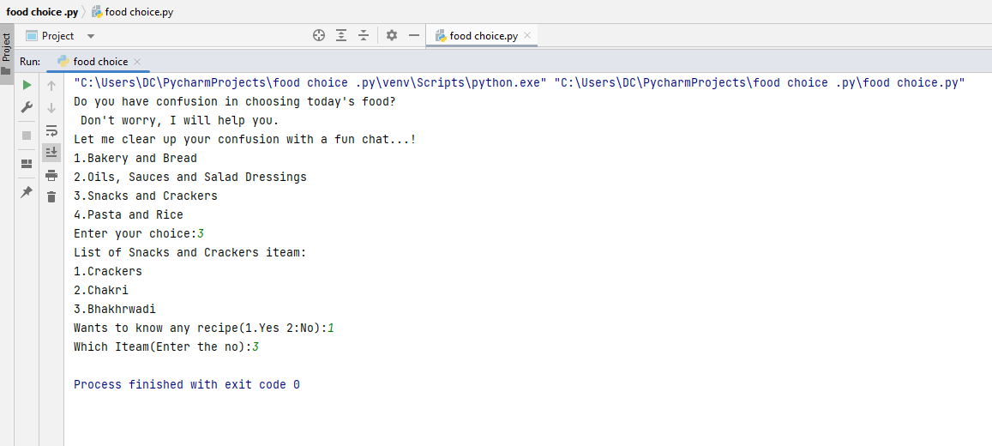

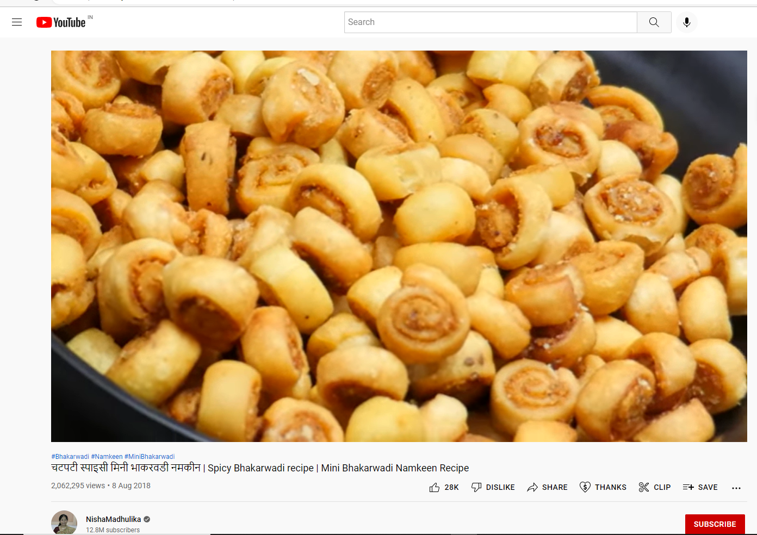

Output 2 :

